Kinematics Review Quiz Multiple Choice Questions
1. Which of the following are VECTOR quantities?
I. position II. speed III. displacement IV. velocity
a. I and III only d. II, III and IV only
b. III and IV only e. I, III and IV only
c. I and IV only

2. Two hikers set out from the same spot and arrive at the same destination but they take different routes.
Which of the following quantities must be the same for both hikers?
a. | distance | d. | average speed
b. | displacement | e. | acceleration
c. | average velocity

3. Which of the following graph(s) does(do) NOT represent uniform motion?
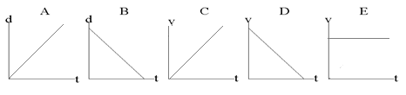

a. | A,B,C and D | d. | A and B
b. | B only | e. | C and D
c. | E only

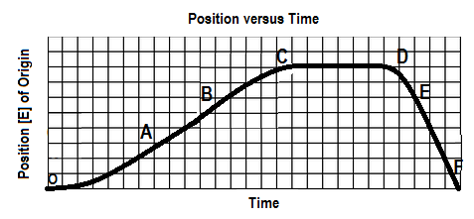
4. The graph below shows a position-time graph

Over which interval is the object moving west and speeding up?
a. OA b. BC c.CD d. DE e.EF

5. A ball is tossed up into the air. At the peak (the highest point in the path), which of the following conditions apply?
a. velocity = 0.0 m/s , acceleration = 0.0 m/s²
b. velocity = 0.0 m/s , acceleration = 9.80 m/s² [down]
c. velocity = 0.0 m/s , acceleration = 9.80 m/s² [up]
d. velocity = 9.80 m/s [up] , acceleration = 0.0 m/s²
e. velocity = 9.80 m/s [down] , acceleration = 0.0 m/s²

6. An object is travelling west and slowing down. The directions associated with the
object’s velocity and acceleration, respectively, are:
a. [W], [W] b. [W], [S] c. [W], [E] d. [E], [W] e. [E], [S]

7. The area under a velocity-time graph represents
a. | displacement | d. | instantaneous velocity
b. | acceleration | e. | average velocity
c. | change in velocity

SPH4U0-Sep 2019 Kinematics Review Quest- Name:_________________
Total: _________/31 marks [K/U]
Useful Equations and Constants:
v_{av} =ΔΔ a =ΔΔ = Δ Δd= ½ (v₁+v₂) Δt Δd=v₂ Δt – ½ a (Δt)²

Δd=v₁ Δt + ½ a (Δt)² Δd = $\frac{v22-v12}{2a}$ g= 9.80 m/s²

Part A: Multiple Choice Answers [ 7 marks]:
Write the letter representing the best answer for each question in the table below:
1 | 2 | 3 | 4 | 5 | 6 | 7

Part B: Short Answer and Problem Solving [ 24 marks]:

- A baseball player slides into home plate with an initial velocity of 10.0 m/s [forward] over a displacement of 12.0 m [forward]. Friction acts against them slowing them down at a rate of 1.67 m/s² [backward]. Find:
- Their final velocity when they reach the plate. [3]
- Their time to reach the plate. [3]

2. A hockey puck slides over smooth ice at a constant velocity of 9.00 m/s [Forward] for 5.00 seconds. It then encounters rough ice and slows down uniformly to stop in 3.00 seconds.
- Sketch the position-time and velocity-time graphs for the puck’s motion. [2]
- Find the total displacement of the puck over the 8.00 second time interval. [3]

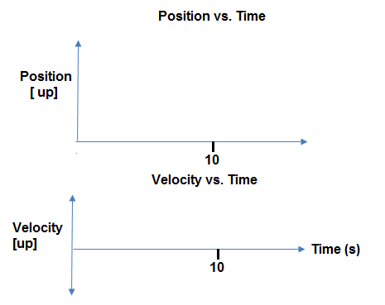

3. Two speed skaters are competing in a practice race. Speedy (S) is very skilled and can skate at a constant speed of 14.0 m/s [F]. She is competing against Newbie (N) who is new to the sport. Newbie can skate at a constant speed of 11.8 m/s [F]. They line up on the start line and Speedy gives Newbie a 2.00 second head start before pursuing him.
- Sketch a d-t graph representing their motions. [1]

- Find the time it takes Speedy to catch up with Newbie and the position from the start line at which she catches him. [4]

Part C: Graph Analysis [8 marks]

1. The motion of a train engine moving along a straight track in a railyard is shown on the velocity-time
graph below.
i) Draw the corresponding acceleration-tine graph for the train. [3]
ii) Assuming that the train starts at the station (origin), draw the corresponding
position-time graph. [5]

Position-Time Graph:

Velocity-Time Graph:
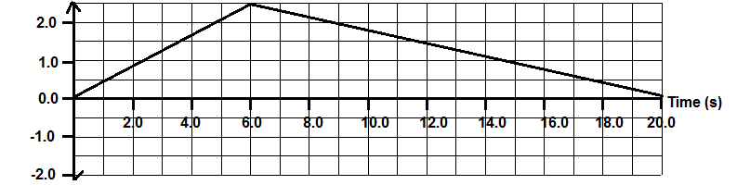

Acceleration-Time Graph:

